**GILES CHEMICAL, A DIVISION OF PREMIER MAGNESIA, LLC**

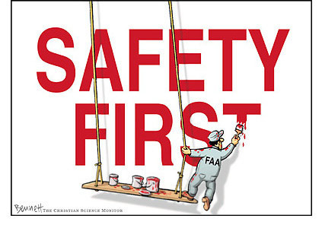

**SAFETY RULES**

1. **Please sign in on Visitor Log. Visitor Logs are located in lower warehouse and in the front office.**
2. **Safety glasses are required throughout the plant. Steel toed shoes are required outside of designated safety zone. – No exceptions.**
3. **Report all injures to Safety Department. No matter how small or severe, all injuries must be reported. If you are bleeding, please have a plant worker to get the ERT member to assist you.**
4. **If you are going to enter a confined space you must fill out a Confined Space Entry Permit. This permit can be obtained from a Giles Chemical supervisor.**
5. **Any equipment to be worked on must Locked, Tagged, & Tried before work begins. Please be sure to inform plant workers of equipment you will be working on or around.**
6. **Always wear fall preventative equipment when it’s needed. If in doubt please ask someone.**

**I have read and understand these safety rules. I agree to adhere to these rules while visiting Giles Chemical, a division of Premier Magnesia, LLC.**

**Signature: _________________________ Visit With:______________ Date:____________**

**01/26/12**

**Rev: 00**